Building Agents with Model Context Protocol - Full Workshop with Mahesh Murag of Anthropic
https://youtu.be/kQmXtrmQ5Zg?si=dkmanbO6TdwR7hvO
~ Prepared by Riya Kharade

- Introduction

Speaker: Mahes, Applied AI Team, Anthropic
Topic: mCP (Model Context Protocol)
Format: Talk with interactive Q&A
Purpose: Explain mCP, its motivation, adoption, and role in AI applications and agent frameworks.
1. Introduction
The Modular Communication Protocol (mCP) is a standardized framework designed to improve communication between AI agents, servers, and tools. It enables agents to dynamically access data, invoke APIs, and evolve their capabilities without manual programming. mCP is transport-agnostic, supporting Standard IO, SSE, HTTP, or custom transports, simplifying AI development, and ensuring secure, scalable, and context-aware workflows.

2. What is mCP
mCP is a protocol that standardizes interactions between AI applications and external systems.
- APIs (Application Programming Interfaces): Standardize how applications interact with each other.
- LSP (Language Server Protocol): Standardizes how IDEs interact with language tools.
- mCP: Standardizes how AI models, agents, and applications interact with servers, tools, and resources.
Key Components of mCP:
- Prompts: User-defined templates for actions.
- Tools: Model-controlled actions (API calls, file updates).
- Resources: Application-controlled data (files, JSON, images).

3. With mCP: Standardized AI Development
Before mCP:
- AI development was fragmented with custom integrations per team.
- Tools and prompts were difficult to reuse.
With mCP:
- Developers can connect any mCP client to any server with zero extra work.
- Teams can share tools and resources seamlessly.
- Promotes modularity, collaboration, and scalability in AI development.

4. Building with mCP
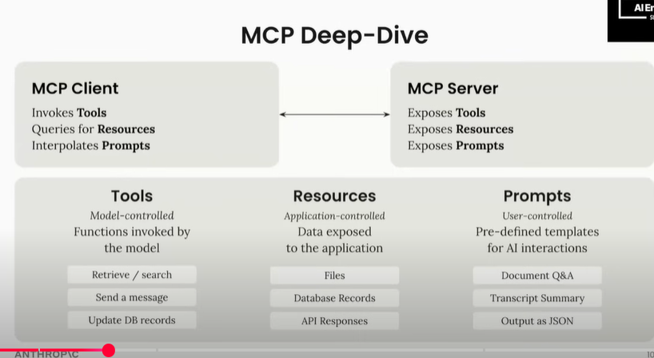
Key principles:
- Transport-Agnostic Communication: Works with Standard IO, SSE, HTTP, or custom transports.
- Self-Evolving Agents: Agents dynamically discover new servers and tools using the mCP registry.
- Verified Access: Ensure only approved servers and tools are used.
- Clear Separation of Control:
  - Model → Tools
  - Application → Resources
  - User → Prompts
Workflow:
- Define agent goals.
- Integrate mCP client.
- Query registry for available tools/servers.
- Execute actions dynamically.
- Enable self-evolution and adaptation.

5. mCP in Action
Use Cases:
- Agents performing tasks such as research, fact-checking, or report writing.
- Dynamically querying servers like Grafana for logs or errors.
- Automatic API calls and tool invocation without predefined knowledge of servers.
- Predefined prompts for summarization, notifications, and structured responses.
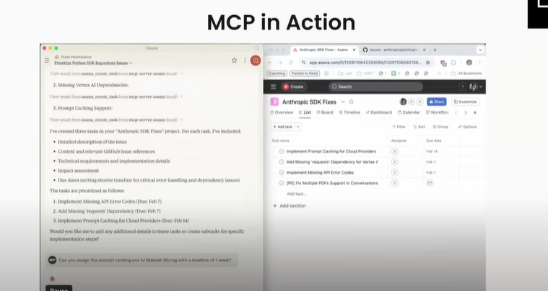
6. mCP and Agents
mCP enhances agent frameworks by providing standard methods to access tools and resources dynamically.
Building Effective Agents with mCP
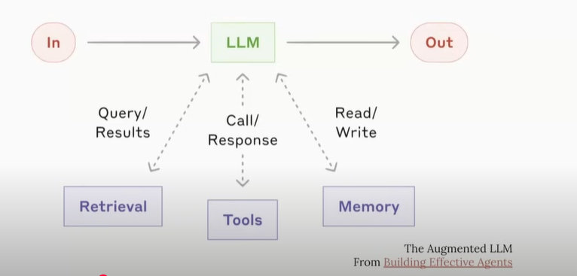
- Self-Evolving: Agents discover new capabilities over time.
- Registry Queries: Find verified servers and tools.
- Proactive Behavior: Agents can request more information or perform tasks automatically.
Sampling
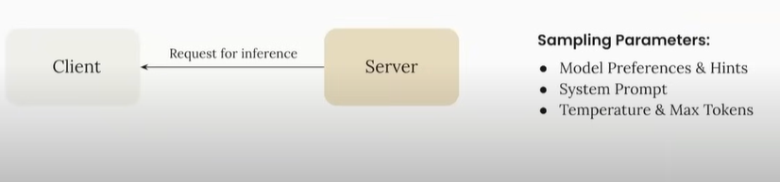
- Agents can test or query multiple tools/resources to determine the best response.
Composability
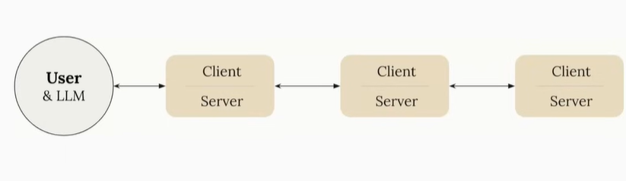
- Agents can combine multiple tools or resources to solve complex tasks efficiently.
Sampling + Composability
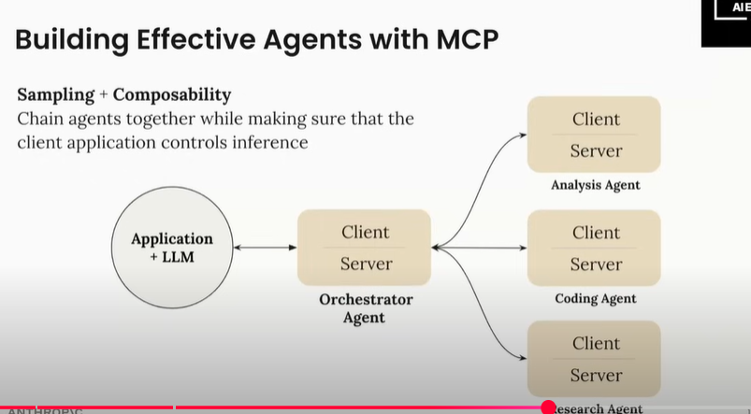
- Agents can sample different tools and compose them dynamically to execute advanced workflows.
7. What’s Next for mCP
Future developments include:
- Stateful vs Stateless Connections: Short-lived connections for efficiency; long-lived for streaming or notifications.
- Streaming Support: Sending chunked data incrementally to clients.
- Namespaces & Conflict Resolution: Avoid naming conflicts across multiple servers/tools.
- Tool Packaging: Logical grouping of related tools (e.g., Finance or Analytics packages).
- Proactive Server Behavior: Servers trigger actions or request information automatically.

8. Official mCP Registry API
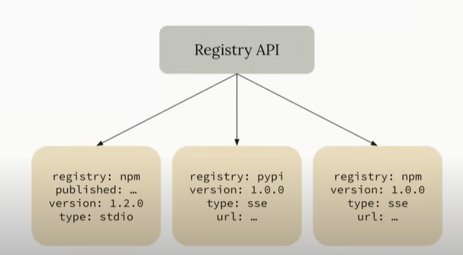
- Centralized registry for discovery and verification of tools and servers.
- Provides metadata about servers, tools, and their capabilities.
- Ensures trusted interactions and reduces security risks.
- Supports dynamic updates without restarting or pre-configuring agents.
9. Server Discovery
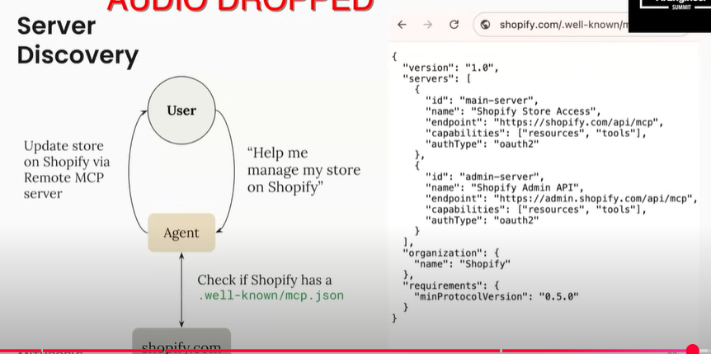
- Dynamic Discovery: Agents query the registry to find new tools and servers.
- Well-Known Endpoints: Verified servers (like Shopify) expose predefined mCP endpoints.
- Security & Verification: Whitelisting or intermediary tools filter access to approved servers.
10. Key Takeaways
- Transport-Agnostic: Works over multiple communication protocols.
- Dynamic & Self-Evolving Agents: Agents discover tools and servers automatically.
- Standardized Development: Reduces fragmentation and promotes modular AI workflows.
- Registry & Verification: Ensures secure, reliable interactions.
- Advanced Features: Supports streaming, namespaces, tool packaging, and proactive behavior.

11. Conclusion
The mCP protocol is a foundational tool for building autonomous, scalable, and secure AI agent systems. It standardizes interactions, promotes reusable tools and resources, and enables agents to adapt, evolve, and compose workflows dynamically. With mCP, AI development becomes more efficient, modular, and capable of handling complex, multi-agent environments.

